Construction Management System
BCA 6th Semester CS-76 PROJECT
Subrata Das

Table of Contents
1. Introduction of the Project: 5
2. Objective of the Project: 7
Tools / Environment Used 8
3. Analysis of the Project: 11
3.1 Existing System 11
3.1.1 Documents maintained: 12
3.1.2 Problem faced in current process: 13
3.2 Proposed Construction Management System 14
3.2.1 ESCMS GUI: 14
3.2.1.1 User Interfaces: 15
3.2.1.2 User Interface Controller: 17
3.2.1.3 Engine Interactor: 17
3.2.2 ESCMS Engine 17
3.2.2.1 Engine Controller: 18
3.2.2.2 GUI Interactor: 18
3.2.2.3 Task Handler: 18
3.2.2.4 Data Entry Handler: 18
3.2.2.5 Customer Request Handler: 19
3.2.2.6 Access Controller: 19
3.2.2.7 Contract Request Handler: 19
3.2.2.8 Search Engine: 19
3.2.2.9 Legacy Format Converter: 19
3.2.2.10 Database Controller: 19
3.2.3 ESCMS Database 19
3.3 Hardware & Software Requirements for the application to run 20
3.3.1 Hardware Requirements 20
3.3.2 Hardware Requirements 20
3.4 E-R Diagram: 21
4 Tools/Platforms used (Hardware/Software): 25
Hardware: 25
Software: 25
5 Design Document: 25
6 Program code: 29
7 Testing: 30
Unit testing 30
Integration Testing 30
System Testing 31
8 Input and output screens: 32
9 Security measures: 32
10 limitations of the project: 32
11 Any Client/Industry: 32
12 Future Scope and Further enhancement of the project: 33
13 Bibliography: 34

Introduction & Objective of the Project:
Construction Management System is software for managing and maintaining a construction site. A construction site has lots of activity going on parallel. Construction management software will enable the site manager to monitor workers, materials used, work progress, planning & estimation of future work.

Figure: Overview of Construction Management System
The main features of this software are given below:
  - Construction design and planning using external designer software
  - Design viewer and add comments.
  - Worker attendance management.
  - Worker Identity info saving and security management
  - Raw material stock & pricing information query.
  - Estimation & planning of future work.
  - Monthly / daily progress report
  - Supply management & payment tracking.
  - Safety assurance
  - Transport management
  - Legal work management
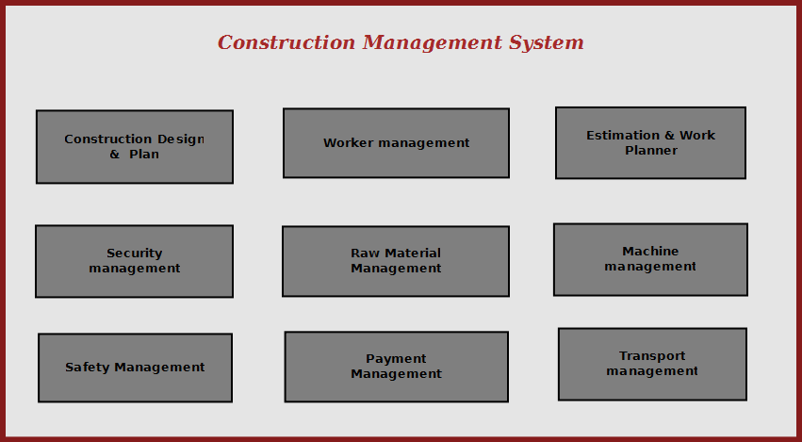

Figure: Overview of Construction Management System
Construction management system will enable the site manager to control all aspects of construction from a standalone solution. It allows to manage, search and refer important data used in construction, It makes site managers life easy to operate construction activities flawlessly.

Project Category:

This software will follow Object Oriented Programming Paradigm and use below mentioned areas.

Front End/ GUI Tools: Visual Studio 2010, .NET 4, C#
Backend: MySQL
Networking Technologies: TCP/IP
Wireless Technologies: Bluetooth
Operating Systems: Windows XP, Windows 7

Tools / Environment Used:
This software will follow Object Oriented Programming Paradigm and use below mentioned areas.

IDE Used ( Visual Studio 2010):

Microsoft Visual Studio is a powerful IDE that ensures quality code throughout the entire application lifecycle, from design to deployment. Whether we are developing applications for SharePoint, the web, Windows, Windows Phone, and beyond, Visual Studio is the ultimate all-in-one solution. Visual Studio includes a code editor supporting IntelliSense as well as code refactoring.
The integrated debugger works both as a source-level debugger and a machine-level debugger. Other built-in tools include a forms designer for building GUI applications, web designer, class designer, and database schema designer. It accepts plug-ins that enhance the functionality at almost every level—including adding support for source-control systems (like Subversion and Visual SourceSafe) and adding new toolsets like editors and visual designers for domain-specific languages or toolsets for other aspects of the software development lifecycle (like the Team Foundation Server client: Team Explorer).

Front End: WPF (Windows Presentation Framework):
Windows Presentation Foundation (WPF) provides developers with a unified programming model for building rich Windows smart client user experiences that incorporate UI, media, and documents. Windows Presentation Foundation (WPF) is a next-generation presentation system for building Windows client applications with visually stunning user experiences. With WPF, you can create a wide range of both standalone and browser-hosted applications. The core of WPF is a resolution-independent and vector-based rendering engine that is built to take advantage of modern graphics hardware. WPF extends the core with a comprehensive set of application-development features that include Extensible Application Markup Language (XAML), controls, data binding, layout, 2-D and 3-D graphics, animation, styles, templates, documents, media, text, and typography. WPF is included in the Microsoft .NET Framework, so you can build applications that incorporate other elements of the .NET Framework class library.

Programming Framework(.NET 4) :

The .NET 4 Framework is Microsoft's platform for building applications that have visually stunning user experiences, seamless and secure communication, and the ability to model a range of business processes. The .Net Framework consists of:
Common Language Runtime – provides an abstraction layer over the operating system
Base Class Libraries – pre-built code for common low-level programming tasks
Development frameworks and technologies – reusable, customizable solutions for larger programming tasks.
The framework's Base Class provides user interface, data access, database connectivity, cryptography, web application development, numeric algorithms, and network communications. The class library is used by programmers, who combine it with their own code to produce applications.

Programming Language ( C#) :
C# is a type-safe, object-oriented language that is simple yet powerful, allowing programmers to build a breadth of applications.
C# is a multi-paradigm programming language encompassing imperative, declarative, functional, generic, object-oriented(class-based), and component-oriented programming disciplines.
It was developed by Microsoft within the .NET initiative and later approved as a standard by Ecma (ECMA-334) and ISO (ISO/IEC 23270). C# is one of the programming languages designed for the Common Language Infrastructure.
C# is intended to be a simple, modern, general-purpose, object-oriented programming language.

EXTENSIBLE MARKUP LANGUAGE (XML)
Extensible Markup Language (XML) is a simple, very flexible text format derived from SGML (ISO 8879). Originally designed to meet the challenges of large-scale electronic publishing, XML is also playing an increasingly important role in the exchange of a wide variety of data on the Web and elsewhere.
Extensible Markup Language (XML) is a set of rules for encoding documents in machine-readable form. It is defined in the XML 1.0 Specification produced by the W3C, and several other related specifications, all gratis open standards.
XML's design goals emphasize simplicity, generality, and usability over the Internet.[6] It is a textual data format with strong support via Unicode for the languages of the world. Although the design of XML focuses on documents, it is widely used for the representation of arbitrary data structures, for example in web services.
Many application programming interfaces (APIs) have been developed that software developers use to process XML data, and several schema systems exist to aid in the definition of XML-based languages.
As of 2009, hundreds of XML-based languages have been developed,[7] including RSS, Atom, SOAP, and XHTML. XML-based formats have become the default for most office-productivity tools, including Microsoft Office (Office Open XML), OpenOffice.org (OpenDocument), and Apple's iWork.
System.Xml is the core XML manipulation technology for .NET languages.

DIA – diagraming tool
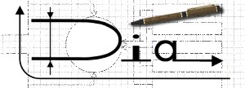
Dia is a GTK+ based diagram creation program for GNU/Linux, Mac OS X, Unix, and Windows. Dia is roughly inspired by the commercial Windows program 'Visio,' though more geared towards informal diagrams for casual use. It can be used to draw many different kinds of diagrams. It currently has special objects to help draw entity relationship diagrams, UML diagrams, flowcharts, network diagrams, and many other diagrams. It is also possible to add support for new shapes by writing simple XML files, using a subset of SVG to draw the shape.
It can load and save diagrams to a custom XML format (gzipped by default, to save space), can export diagrams to a number of formats, including EPS, SVG, XFIG, WMF and PNG, and can print diagrams (including ones that span multiple pages).

NClass – UML diagraming tool

NClass is a free tool to easily create UML class diagrams with full C# and Java language support. The user interface is designed to be simple and user-friendly for easy and fast development. Properties, enums, delegates and other language specific elements are fully supported with strict syntactical and semantical verification.
Design your application with just a few clicks - the main goal is to provide a simple but powerful class designer that is very intuitive to use. Diagram styles help you to create professional looking diagrams, just like in Visual Studio or other commercial products. Furthermore, you can generate code from your models or you can also import classes from existing .NET assemblies.
Features
- Full C# and Java support with many language specific elements
- Simple and easy to use user interface
- Inline class editors with syntactic parsers for easy and fast editing
- Source code generation
- Reverse engineering from .NET assemblies (thanks to Malte Ried)
- Configurable diagram styles
- Printing / saving to image
- Multilingual user interface
- Mono support for non-Windows users

Database - MySQL

MySQL is the world's most popular open source database software, with over 100 million copies of its software downloaded or distributed throughout its history. With its superior speed, reliability, and ease of use, MySQL has become the preferred choice for Web, Web 2.0, SaaS, ISV, Telecom companies and forward-thinking corporate IT Managers because it eliminates the major problems associated with downtime, maintenance and administration for modern, online applications.
MySQL is a key part of LAMP (Linux, Apache, MySQL, PHP / Perl / Python), the fast-growing open source enterprise software stack. More and more companies are using LAMP as an alternative to expensive proprietary software stacks because of its lower cost and freedom from platform lock-in.
MySQL Community Edition is the freely downloadable version of the world's most popular open source database. It is available under the GPL license and is supported by a huge and active community of open source developers.
The MySQL Community Edition includes:
- Pluggable Storage Engine Architecture
- Multiple Storage Engines: InnoDB , MyISAM, NDB (MySQL Cluster),Memory ,Merge , Archive, CSV
- MySQL Replication to improve application performance and scalability
- MySQL Partitioning to improve performance and management of large database applications
- Stored Procedures to improve developer productivity
- Triggers to enforce complex business rules at the database level
- Views to ensure sensitive information is not compromised
- Information Schema to provide easy access to metadata
- MySQL Connectors (ODBC, JDBC, .NET) for building applications in multiple languages
- MySQL Workbench for visual modeling, SQL development and administration

MySQL Workbench
MySQL Workbench is a unified visual tool for database architects, developers, and DBAs. MySQL Workbench provides data modeling, SQL development, and comprehensive administration tools for server configuration, user administration, and much more. MySQL Workbench is available on Windows, Linux and Mac OS.
- Design
MySQL Workbench enables a DBA, developer, or data architect to visually design, model, generate, and manage databases. It includes everything a data modeler needs for creating complex ER models, forward and reverse engineering, and also delivers key features for performing difficult change management and documentation tasks that normally require much time and effort.
- Develop
MySQL Workbench delivers visual tools for creating, executing, and optimizing SQL queries. The SQL Editor provides color syntax highlighting, reuse of SQL snippets, and execution history of SQL. The Database Connections Panel enables developers to easily manage database connections. The Object Browser provides instant access to database schema and objects.
- Administer
MySQL Workbench provides a visual console to easily administer MySQL environments and gain better visibility into databases. Developers and DBAs can use the visual tools for configuring servers, administering users, and viewing database health.
Front End/ GUI Tools: Visual Studio 2010, .NET 4, C#
Backend: MySQL, MySQL .NET Connector, XML
Internet Technologies: HTML, JavaScript, PHP, Google App Framework
Networking Technologies: TCP/IP
Operating Systems: Windows XP, Windows 7
Applications: ERP application, Database Management System.

Analysis of the Project:
Construction Management System will provide a cost effective & efficient software solution for managing everything about Construction . Different components of Construction Management System are depicted below.

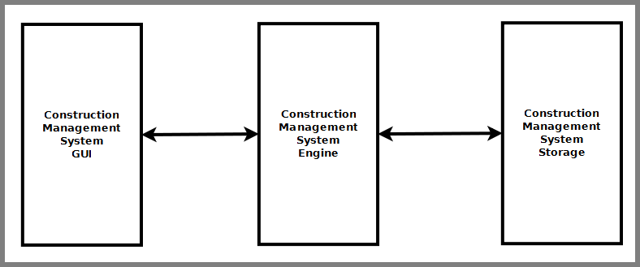
Figure: Components of Construction Management System

Construction Management System is divided into three main components. Such as:
- Construction Management System GUI
- Construction Management System Engine
- Construction Management System Database

Construction Management System GUI
Construction Management System GUI will allow users to view existing construction data, enter new data & modify existing data. It will have a user friendly interface so that user can use the software efficiently. It is divided into six modules. Such as:
- Design & Plan viewer
- Work Planner Interface
- Payment Interface
- Material Management Interface
- Worker Management Interface
- Safety & Security Management Interface

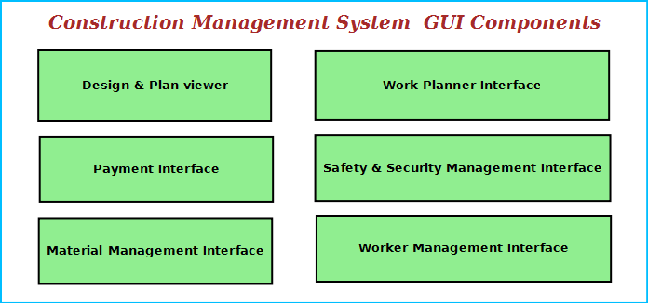
Figure: Construction Management System GUI Components

Design & Plan Viewer
It will allow to view design & planning file using some external editors & viewer. It will also allow scanning existing plan and view it as a image file. Users can add comments for modification and also generate reports.

Work Planner Interface
This interface will allow user to plan and estimate future work. It will have link to worker management interface so that workers can be assigned certain work. It will also enable to add costing and budget data for the work. It will have a option to add legal data associated with a work item and instruction to be followed.

Material Management Interface
This interface will allow user to manage the material used for construction.
    - to search any kind of material of the Construction and view price information and stock details.
    - Enter & modify material availability and usage data.

Payment Interface
This interface will allow users to enter payment data associated with various aspects construction work.
    - Workers payment
    - Raw materials purchase information
    - Future budgets
    - Infrastructure payments.
    - Loan information
    - cash flow and cheque information
    - bank information

Worker Management Interface
This module will maintain information about workers.
    - Construction sites need to maintain the worker personal data, professional experience info.
    - This will allow to track workers attendance and work hours data.
    - This interface will allow managing security measures to taken about the workers. It will have a interface for entering the worker’s security data, photo and scan the photo identity card of the worker.

Safety &Security Management Interface
This interface will ensure safety & security of the construction site.
    - Video Surveillance Interface: This interface will display the video of specific areas of the Construction and save the video for future reference. The site manager can monitor from video surveillance window.
    - First Aid browser : This display the location first aid boxes and instructions on what to do in case of emergency.
    - Emergency contact interface: This will allow user to call ambulance driver, doctor & hospital in case of emergency.

Construction Management System Engine
Construction Management System Engine controls the overall system. It provides logical and tactical solutions for managing the whole system. The Construction Management System is divided into 12 divided modular components. Such as:
- Engine controller | - Raw Material Controller
- GUI Interactor | - Machine & Transport Controller
- Database Controller | - Payment Handler
- Plan & Design Controller | - Search Engine
- Worker Controller | - Safety Controller
- Work Estimation Handler | - Security Controller
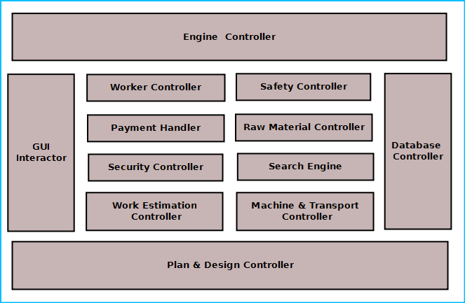
Figure: Components of Engine

Engine controller:
This controls the overall interaction between all the backend modules. It schedules the priority of the actions in case of overlapping. It helps user to consolidate overall reports and print them from GUI.

GUI Interactor:
It interacts with the GUI and polls GUI calls. It exposes APIs and events for GUI to use. GUI Interactor helps Engine to maintain wrapper around the Engine modules so that the GUI can be ported to any other framework without much changes in Engine code.

Database Controller:
It controls the database interactions. It forms query to fetch information from the database. It also sends data to be saved in database for future use.

Plan & Design Controller:
It allows integration with other designer software to view the design. It processes the design comments and helps generating reports.

Worker Controller:
It keeps track of worker information. It has an algorithm for maintaining worker data like
    - Attendance information
    - Work hours
    - Area of expertise
    - Payment details
    - Personal data
All these data will saved and are available for other modules to use and modify.

Security Controller:
It saves information for security measures. It can send it to the authority or police whenever required. It will ensures state of the existing security measures and generate warning if one of the steps is breached.

Safety Controller:
It ensures the safety of the construction site. It controls the safety alarms, fire alarms and instructions to be displayed at the hazardous places.

Work Estimation Controller:
This will allow users to estimate future work depending on the design,deadline and workers expertise. It will have algorithms to control estimation and assignment of work to the workers.

Raw Material Controller:
This module will maintain the information about raw materials. It will derive the figures about available materials, required amount to meet requirements, purchase deadline and allowable stock. It will save the information in database and retrieve them when required.

Search Engine:
Search engine enables rapid and efficient searching of data about workers, raw materials and suppliers. Search Engine prepares search indexes depending most accessed data. It improves the efficiency and performance of the software.

Payment Handler:
Payment Handler allows generating the report for material purchases. It calculates the salary of a worker. It will get the work & salary information from the database depending on worker data and calculates the payable amount.

Machine & Transport Controller:
This module keeps track machine to be used by the construction workers, machine purchase or hiring information, vendor information. This also handles logistics transport, worker transport.

CONSTRUCTION MANAGEMENT System Database
Construction Management System will maintain a centralized database for storing information. We will design a RDBMS to manage the database and engine interaction. It will have optimized design and archive older data to save space and increase performance.

Hardware & Software Requirements for the application to run

Hardware Requirements

Computer that has
- a 1.6GHz or faster processor
- Security Cameras
- 1 GB (32 Bit) or 2 GB (64 Bit) RAM
- Barcode Reader
- 10 MB of available hard disk space
- Report Printing Machine
- DVD-ROM Drive / USB Port Webcam
- Weight Machine

Software Requirements

- Windows XP (x86) with Service Pack 3 / Windows Vista (x86 & x64) with Service Pack 2 / Windows 7 (x86 & x64)
- Microsoft .NET 4.0
- Windows WPF & WCF

Design Document:

Class Diagram

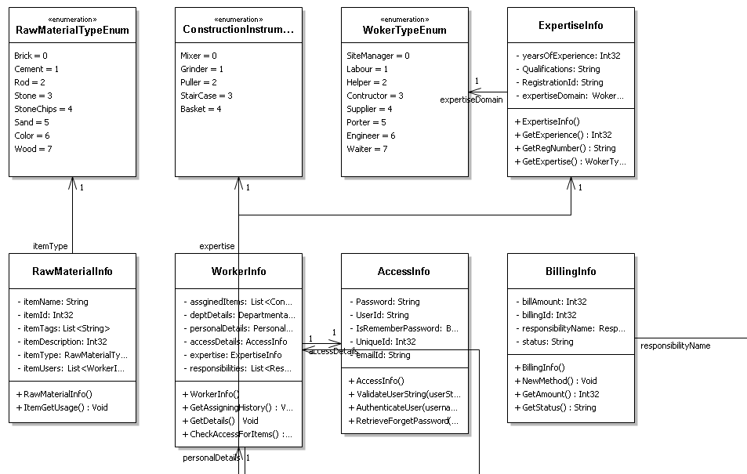
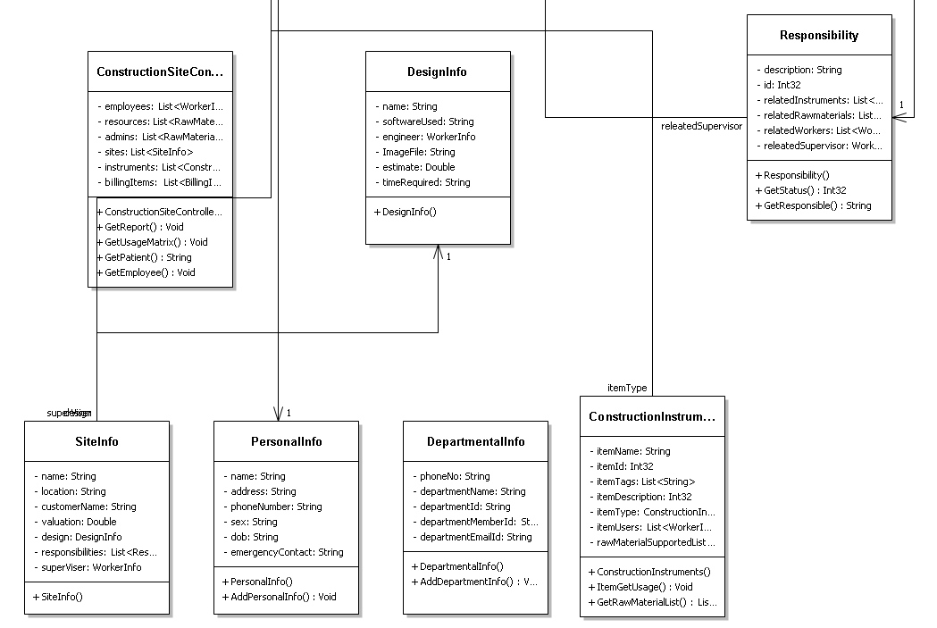
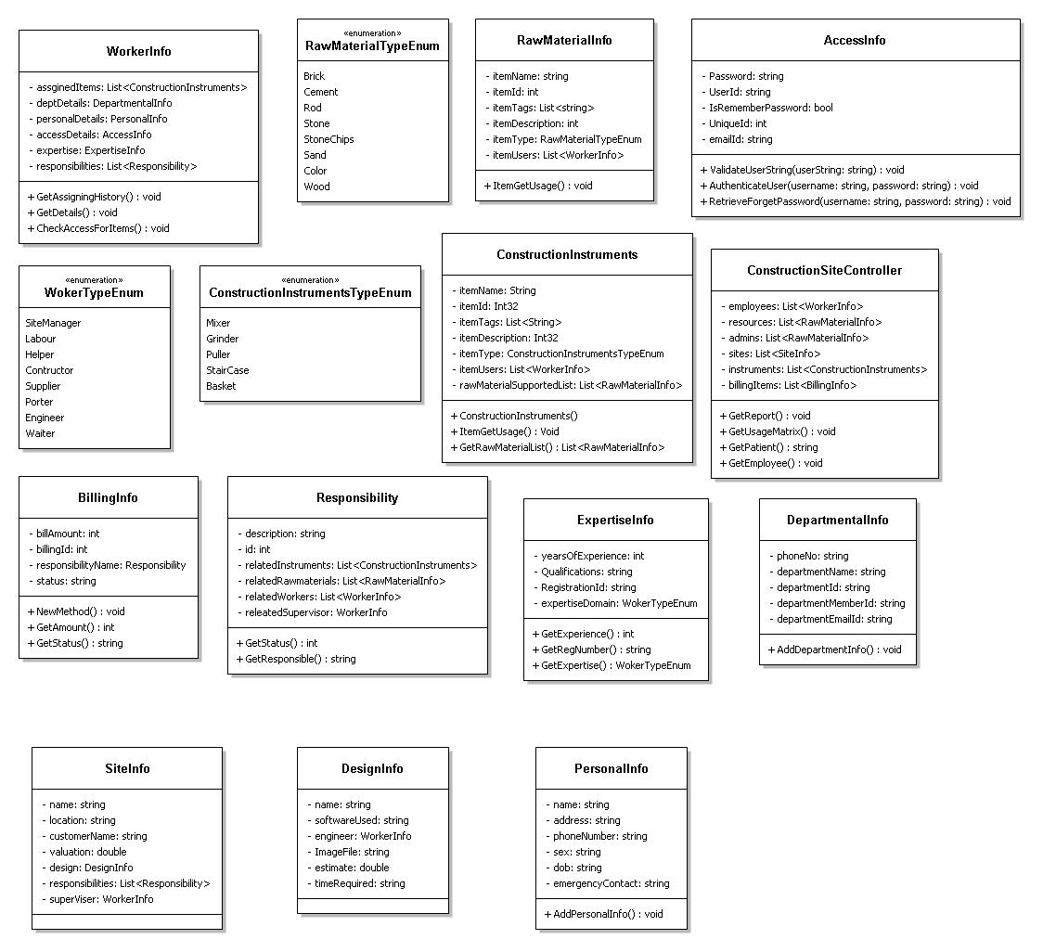

Data Flow Diagram

DFD Level 0
Construction Management System
Design & planning Management
Payment Management
Material Management
Security Management
Machine Management
Worker Management
Safety Management
Design_DB
Worker_DB
Security_DB
Material_DB
Machine_DB
Account_DB
Machine avail.
Worker Alottment
plan & design assign.
Issuing Security
no. of material,allotment
no. of material,allotment

DFD level 1

Worker_DB
Manager
User
Worker
Engineer
Machine
Design_DB
Design & planning Management
Worker Management
Control management
Manages
Construction Details
Machine_DB
Engg._DB
Worker_DB

DFD level 2
Task
Raw_mat
Engg.
Supervisor
Worker
Instruments
Supervision
Responsibility
Maintenances
Task_alltmnt

Flow Diagram
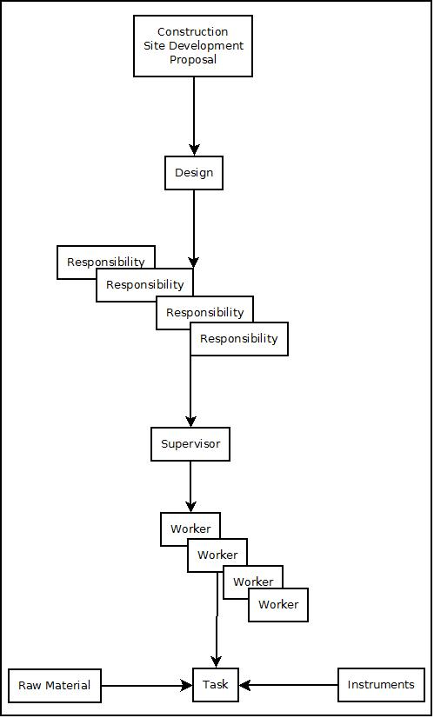

E-R Diagram:
We will design a RDBMS for Construction Management System. The entities and their attributes are listed below. Attributes in Bold letter is the unique key.

Entities | Attributes
Worker | User Id, Name, Address , Contact Number, skillset, Photo ID Num, Photo
Construction Management System | Construction site Id , Name, Address, Registered no
Construction Machine | Machine Id, Name, purpose
Work Session | Session Id, worker Id, Time, Expense amount
Engineer | engineer Id, Name, address, contact number
Design Preference | Preference Id, Type, Description
Raw Material | Product id, stock, name, price

Relationship between Entities:

- Construction Management System has Workers→ 1 : N
- Construction Management System has Machines→ 1 : N
- Workers does Work Session→ 1 : 1
- Construction Management System manages Raw Material → 1 : N
- Engineer provides Design Preferences → M : N

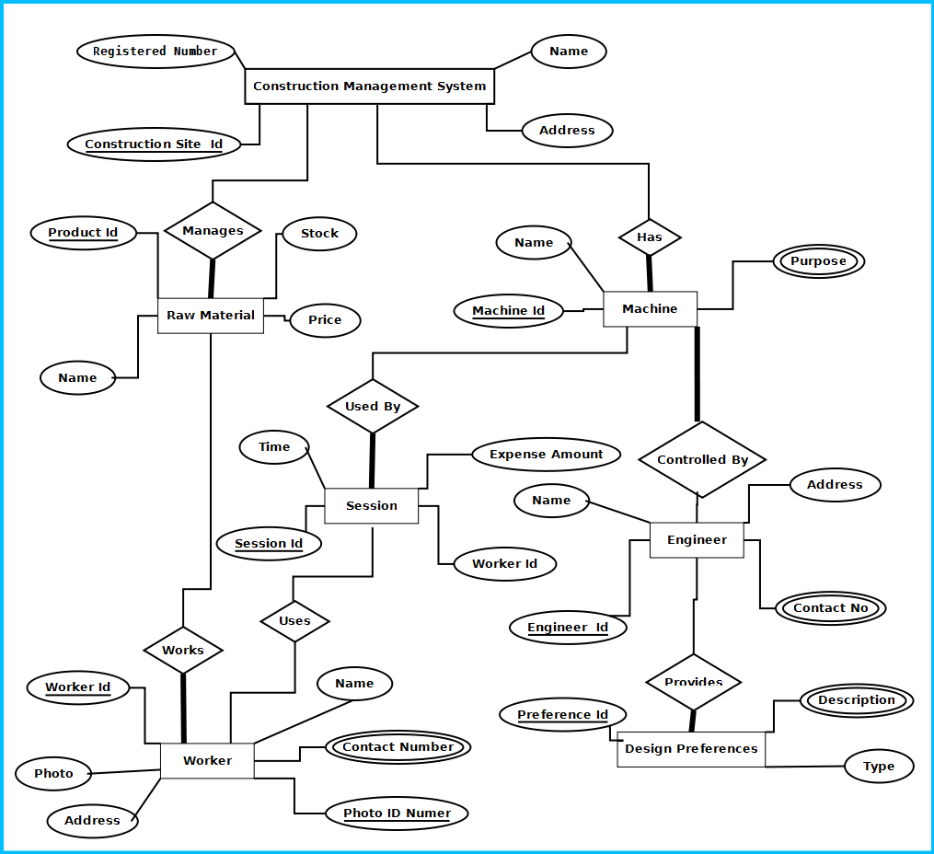
Figure: E-R Diagram of Construction management system

The user interface:
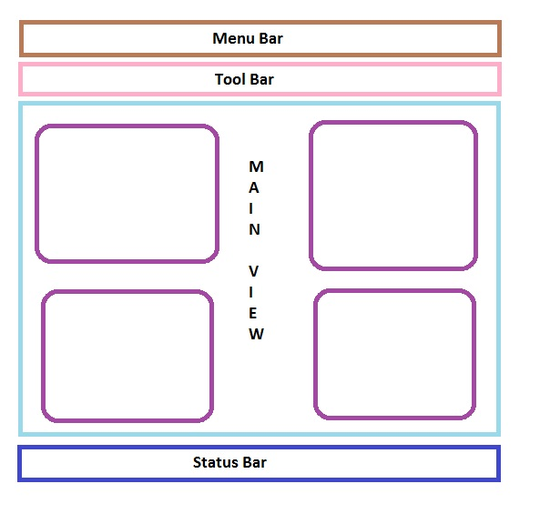

PROGRAMME CODE:

API Used for GUI
Menu bar contains the important features which can be accessed by shortcuts too. It is implemented using Menu control.
System.Windows.Controls.Menu
Namespace: System.Windows.Controls
Assembly: PresentationFramework (in PresentationFramework.dll)
Represents a Windows menu control that enables you to hierarchically organize elements associated with commands and event handlers.

Toolbar lists down the mostly used features. It is implemented using ToolBar control.
System.Windows.Controls.ToolBar
Namespace: System.Windows.Controls
Assembly: PresentationFramework (in PresentationFramework.dll)
Provides a container for a group of commands or controls.

Left navigation bar displays the tutorials available locally and online. This navigation bar is hide- able. It is implemented using the Expander control.
System.Windows.Controls.Expander
Namespace: System.Windows.Controls
Assembly: PresentationFramework (in PresentationFramework.dll)
Represents the control that displays a header that has a collapsible window that displays content.

The local contents are displayed in a TreeView control. And every contents are displayed in in a TreeViewItem.
System.Windows.Controls.TreeView
Namespace: System.Windows.Controls
Assembly: PresentationFramework (in PresentationFramework.dll)
Represents a control that displays hierarchical data in a tree structure that has items that can expand and collapse.

Online contents are displayed in a WebBrowser control. Users can select the content and purchase it from there.
System.Windows.Controls.WebBrowser
Namespace: System.Windows.Controls
Assembly: PresentationFramework (in PresentationFramework.dll)
Hosts and navigates between HTML documents. Enables interoperability between WPF managed code and HTML script.

Textpane displays the Texts. This is implemented using a TextBlock control.
System.Windows.Controls.TextBlock
Namespace: System.Windows.Controls
Assembly: PresentationFramework (in PresentationFramework.dll)
Provides a lightweight control for displaying small amounts of flow content.

Video and audio playing is implemented using MediaElement control.
System.Windows.Controls.MediaElement
Namespace: System.Windows.Controls
Assembly: PresentationFramework (in PresentationFramework.dll)
Represents a control that contains audio and/or video.

Images are displayed using Image control.
System.Windows.Controls.Image
Namespace: System.Windows.Controls
Assembly: PresentationFramework (in PresentationFramework.dll)
Represents a control that displays an image.

Drawing pane is implemented using InkCanvas control.
System.Windows.Controls.InkCanvas
Namespace: System.Windows.Controls
Assembly: PresentationFramework (in PresentationFramework.dll)
Defines an area that receives and displays ink strokes.

Statusbar displays the information about the application and the tutorial currently running. It’s implemented using StatusBar Class.
System.Windows.Controls.Primitives.StatusBar
Namespace: System.Windows.Controls.Primitives
Assembly: PresentationFramework (in PresentationFramework.dll)
Represents a control that displays items and information in a horizontal bar in an application window.

API Used For Engine:
Reading & Writing XML:
In this application the tutorials are saved as XML file. The application will process the XML and play the tutorial. So we have implemented XML reader and writer logic. XML operations are done using .NET XML parser. Every XML element is represented as a XElement control.
System.Xml.Linq.XElement
Namespace: System.Xml.Linq
Assembly: System.Xml.Linq (in System.Xml.Linq.dll)
Represents an XML element.

It has a well-designed Database in MSSQL to save all the information.

Source Code

Source Code Hierarchy
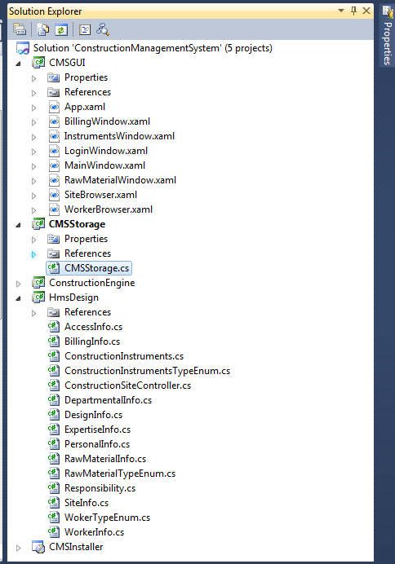

AccessInfo.cs
using System;
using System.Collections.Generic;
using System.Text;

namespace ConstructionManagementSystem.CmsDesign
{
public class AccessInfo
{
string Password;
string UserId;
bool IsRememberPassword;
int UniqueId;
string emailId;

public void ValidateUserString(string userString)
{
throw new NotImplementedException();
}

public void AuthenticateUser(string username, string password)
{
throw new NotImplementedException();
}

public void RetrieveForgetPassword(string username, string password)
{
throw new NotImplementedException();
}
}
}

BillingInfo.cs
using System;
using System.Collections.Generic;
using System.Text;

namespace ConstructionManagementSystem.CmsDesign
{
public class BillingInfo
{
int billAmount;
int billingId;
Responsibility responsibilityName;
string status;

public void NewMethod()
{
throw new NotImplementedException();
}

public int GetAmount()
{
throw new NotImplementedException();
}

public string GetStatus()
{
throw new NotImplementedException();
}
}
}

public int GetAmount()
{
throw new NotImplementedException();
}

public string GetStatus()
{
throw new NotImplementedException();
}
}
}

DepartmentalInfo.cs
using System;
using System.Collections.Generic;
using System.Text;

namespace ConstructionManagementSystem.CmsDesign
{
public class DepartmentalInfo
{
string phoneNo;
string departmentName;
string departmentId;
string departmentMemberId;
string departmentEmailId;

public void AddDepartmentInfo()
{
throw new NotImplementedException();
}
}
}

ConstructionInstruments.cs
using System;
using System.Collections.Generic;
using System.Text;

namespace ConstructionManagementSystem.CmsDesign
{
public class ConstructionInstruments
{
string itemName;
string itemId;
List<string> itemTags;
string itemDescription;
ConstructionInstrumentsTypeEnum itemType;
List<WorkerInfo> itemUsers;
List<RawMaterialInfo> rawMaterialSupportedList;

public void ItemGetUsage()
{
throw new NotImplementedException();
}

public List<RawMaterialInfo> GetRawMaterialList()
{
throw new NotImplementedException();
}
}
}

ConstructionInstrumentsTypeEnum.cs
using System;
using System.Collections.Generic;
using System.Text;

namespace ConstructionManagementSystem.CmsDesign
{
public enum ConstructionInstrumentsTypeEnum
{
Mixer,
Grinder,
Puller,
StairCase,
Basket
}
}

ExpertiseInfo.cs
using System;
using System.Collections.Generic;
using System.Text;

namespace ConstructionManagementSystem.CmsDesign
{
public class ExpertiseInfo
{
int yearsOfExperience;
string Qualifications;
string RegistrationId;
WokerTypeEnum expertiseDomain;

public int GetExperience()
{
throw new NotImplementedException();
}

public string GetRegNumber()
{
throw new NotImplementedException();
}

public WokerTypeEnum GetExpertise()
{
throw new NotImplementedException();
}
}
}

ConstructionSiteController.cs
using System;
using System.Collections.Generic;
using System.Text;

namespace ConstructionManagementSystem.CmsDesign
{
public class ConstructionSiteController
{
List<WorkerInfo> employees;
List<RawMaterialInfo> resources;
List<RawMaterialInfo> admins;
List<SiteInfo> sites;
List<ConstructionInstruments> instruments;
List<BillingInfo> billingItems;

public void GetReport()
{
throw new NotImplementedException();
}

public void GetUsageMatrix()
{
throw new NotImplementedException();
}

public string GetPatient()
{
throw new NotImplementedException();
}

public void GetEmployee()
{
throw new NotImplementedException();
}
}
}

DesignInfo.cs
using System;
using System.Collections.Generic;
using System.Text;

namespace ConstructionManagementSystem.CmsDesign
{
public class DesignInfo
{
string name;
string softwareUsed;
WorkerInfo engineer;
string ImageFile;
double estimate;
string timeRequired;
}
}

RawMaterialInfo.cs
using System;
using System.Collections.Generic;
using System.Text;

namespace ConstructionManagementSystem.CmsDesign
{
public class RawMaterialInfo
{
string itemName;
int itemId;
List<string> itemTags;
int itemDescription;
RawMaterialTypeEnum itemType;
List<WorkerInfo> itemUsers;

public void ItemGetUsage()
{
throw new NotImplementedException();
}
}
}

RawMaterialTypeEnum.cs
using System;
using System.Collections.Generic;
using System.Text;

namespace ConstructionManagementSystem.CmsDesign
{
public enum RawMaterialTypeEnum
{
Brick,
Cement,
Rod,
Stone,
StoneChips,
Sand,
Color,
Wood
}
}

PersonalInfo.cs
using System;
using System.Collections.Generic;
using System.Text;

namespace ConstructionManagementSystem.CmsDesign
{
public class PersonalInfo
{
string name;
string address;
string phoneNumber;
string sex;
string dob;
string emergencyContact;

public void AddPersonalInfo()
{
throw new NotImplementedException();
}
}
}

SiteInfo.cs
using System;
using System.Collections.Generic;
using System.Text;

namespace ConstructionManagementSystem.CmsDesign
{
public class SiteInfo
{
string name;
string location;
string customerName;
double valuation;
DesignInfo design;
List<Responsibility> responsibilities;
WorkerInfo superViser;
}
}

Responsibility.cs
using System;
using System.Collections.Generic;
using System.Text;

namespace ConstructionManagementSystem.CmsDesign
{
public class Responsibility
{
string description;
int id;
List<ConstructionInstruments> relatedInstruments;
List<RawMaterialInfo> relatedRawmaterials;
List<WorkerInfo> relatedWorkers;
WorkerInfo releatedSupervisor;

public int GetStatus()
{
throw new NotImplementedException();
}

public string GetResponsible()
{
throw new NotImplementedException();
}
}
}

WokerTypeEnum.cs
using System;
using System.Collections.Generic;
using System.Text;

namespace ConstructionManagementSystem.CmsDesign
{
public enum WokerTypeEnum
{
SiteManager,
Labour,
Helper,
Contructor,
Supplier,
Porter,
Engineer,
Waiter
}
}

WorkerInfo.cs
using System;
using System.Collections.Generic;
using System.Text;

namespace ConstructionManagementSystem.CmsDesign
{
public class WorkerInfo
{
List<ConstructionInstruments> assginedItems;
DepartmentalInfo deptDetails;
PersonalInfo personalDetails;
AccessInfo accessDetails;
ExpertiseInfo expertise;
List<Responsibility> responsibilities;

public void GetAssigningHistory()
{
throw new NotImplementedException();
}

public void GetDetails()
{
throw new NotImplementedException();
}

public void CheckAccessForItems()
{
throw new NotImplementedException();
}
}
}

VideoSurveillance.xaml
<Window x:Class="CyberCafeController.VideoSurveillance"
xmlns="http://schemas.microsoft.com/winfx/2006/xaml/presentation"
xmlns:x="http://schemas.microsoft.com/winfx/2006/xaml"
Title="VideoSurveillance" Height="307" Width="339">
<Grid Height="270">
<Grid.RowDefinitions>
<RowDefinition Height="226*" />
<RowDefinition Height="36*" />
</Grid.RowDefinitions>
<MediaElement x:Name="MediaEL" Grid.RowSpan="1" LoadedBehavior="Manual" />
<StackPanel Orientation="Horizontal" Grid.Row="1" HorizontalAlignment="Center" Margin="8,0,8,5" Width="301">
<Button x:Name="btnRec" Content="Record" Click="btnRec_Click"
Width="50" Height="25"/>
<Button x:Name="btnPlay" Content="Play" Click="btnPlay_Click"
Width="50" Height="25"/>
<Button x:Name="btnStop" Content="Stop" Click="btnStop_Click"
Width="50" Height="25"/>
<Button x:Name="btnMoveBackward" Content="Back" Click="btnMoveBackward_Click"
Width="50" Height="25"/>
<Button x:Name="btnMoveForward" Content="Forward" Click="btnMoveForward_Click"
Width="50" Height="25"/>
<Button x:Name="btnOpen" Content="Open" Click="btnOpen_Click"
Width="50" Height="25"/>
</StackPanel>
</Grid>
</Window>

VideoSurveillance.xaml.cs
using System;
using System.Collections.Generic;
using System.Linq;
using System.Text;
using System.Windows;
using System.Windows.Controls;
using System.Windows.Data;
using System.Windows.Documents;
using System.Windows.Input;
using System.Windows.Media;
using System.Windows.Media.Imaging;
using System.Windows.Shapes;

namespace ConstructionController
{
/// <summary>
/// Interaction logic for VideoSurveillance.xaml
/// </summary>
public partial class VideoSurveillance : Window
{
public VideoSurveillance()
{
InitializeComponent();
IsPlaying(false);
}

private void btnRec_Click(object sender, RoutedEventArgs e)
{

}
#region IsPlaying(bool)
private void IsPlaying(bool bValue)
{
btnStop.IsEnabled = bValue;
btnMoveBackward.IsEnabled = bValue;
btnMoveForward.IsEnabled = bValue;
btnPlay.IsEnabled = bValue;
}
#endregion

#region Play and Pause
private void btnPlay_Click(object sender, RoutedEventArgs e)
{
IsPlaying(true);
if (btnPlay.Content.ToString() == "Play")
{
MediaEL.Play();
btnPlay.Content = "Pause";
}
else
{
MediaEL.Pause();
btnPlay.Content = "Play";
}
}
#endregion

#region Stop
private void btnStop_Click(object sender, RoutedEventArgs e)
{
MediaEL.Stop();
btnPlay.Content = "Play";
IsPlaying(false);
btnPlay.IsEnabled = true;
}
#endregion

#region Back and Forward
private void btnMoveForward_Click(object sender, RoutedEventArgs e)
{
MediaEL.Position = MediaEL.Position + TimeSpan.FromSeconds(10);
}

private void btnMoveBackward_Click(object sender, RoutedEventArgs e)
{
MediaEL.Position = MediaEL.Position - TimeSpan.FromSeconds(10);
}
#endregion

#region Open Media
private void btnOpen_Click(object sender, RoutedEventArgs e)
{
Microsoft.Win32.OpenFileDialog ofd = new Microsoft.Win32.OpenFileDialog();
ofd.Filter = "Video Files (*.wmv)|*.wmv";
if (ofd.ShowDialog() == true)
{
MediaEL.Source = new Uri(ofd.FileName);
btnPlay.IsEnabled = true;
}
}
#endregion
}
}

ConstructionStorage.cs
using System;
using System.Collections.Generic;
using System.Linq;
using System.Text;

namespace ConstructionStorage
{
public class ConstructionStorage
{

#region database interction data fetching

MySql.Data.MySqlClient.MySqlConnection msqlConnection = null;

private void fetcheUserData()
{
msqlConnection = new MySql.Data.MySqlClient.MySqlConnection("server=localhost;user id=root;Password=technicise;database=sptdb;persist security info=False");
try
{ //define the command reference
MySql.Data.MySqlClient.MySqlCommand msqlCommand = new MySql.Data.MySqlClient.MySqlCommand();
msqlCommand.Connection = msqlConnection;

msqlConnection.Open();

msqlCommand.CommandText = "Select * from Users;";
MySql.Data.MySqlClient.MySqlDataReader msqlReader = msqlCommand.ExecuteReader();
_UsersCollection.Clear();

while (msqlReader.Read())
{
UsersData UsersDataObject = new UsersData();

//UsersDataObject.serialNo = msqlReader.GetString("sl_no");
UsersDataObject.UserAdress = msqlReader.GetString("address");
UsersDataObject.phoneNumber = msqlReader.GetString("ph_no");
UsersDataObject.UserName = msqlReader.GetString("User_name");
UsersDataObject.UserVatNo = msqlReader.GetString("vat_no");
UsersDataObject.UserId = msqlReader.GetString("id");
UsersDataObject.UserTurnOver = msqlReader.GetString("turn_over");
UsersDataObject.UserDue = msqlReader.GetString("due");
_UsersCollection.Add(UsersDataObject);

}

}
catch (Exception er)
{
MessageBox.Show(er.Message);
}
finally
{
//always close the connection
msqlConnection.Close();
}
}
#endregion

#region User table update

private void UpdateUserTable()
{

//define the connection reference and initialize it
msqlConnection = new MySql.Data.MySqlClient.MySqlConnection("server=localhost;user id=root;Password=technicise;database=sptdb;persist security info=False");

try
{
//define the command reference
MySql.Data.MySqlClient.MySqlCommand msqlCommand = new MySql.Data.MySqlClient.MySqlCommand();

//define the connection used by the command object
msqlCommand.Connection = msqlConnection;

double dbDue = 0.0;
double dbTurnOver = 0.0;

//open the connection
if (msqlConnection.State != System.Data.ConnectionState.Open)
msqlConnection.Open();
string cusIdKey = UserInfoTb.SelectedValue.ToString();
string cmdStr = "SELECT turn_over,due FROM Users WHERE id='" + cusIdKey + "';";
msqlCommand.CommandText = cmdStr;

MySql.Data.MySqlClient.MySqlDataReader msqlReader = msqlCommand.ExecuteReader();

while (msqlReader.Read())
{
dbDue = double.Parse(msqlReader.GetString("due"));
dbTurnOver = double.Parse(msqlReader.GetString("turn_over"));
}

if (msqlConnection.State == System.Data.ConnectionState.Open)
msqlConnection.Close();

//updating the value
if (msqlConnection.State != System.Data.ConnectionState.Open)
msqlConnection.Open();

double totalBilledAmount = CalculateTotalAmount() + CalculateVAT();

double newDueDouble = dbDue + totalBilledAmount - double.Parse(paymentAmountTB.Text);
String newDue = newDueDouble.ToString();
String newTurnOver = (dbTurnOver + totalBilledAmount).ToString();
msqlCommand.CommandText = "UPDATE Users SET due='" + newDue + "', turn_over='" + newTurnOver + "' WHERE id='" + cusIdKey + "'; ";

msqlCommand.ExecuteNonQuery();

}
catch (Exception er)
{
MessageBox.Show(er.Message);
}
finally
{
if (msqlConnection.State == System.Data.ConnectionState.Open)
msqlConnection.Close();
}

}

#endregion
}
}

AddNewDoctorWindow.xaml
<Window x:Class="doctors.AddNewDoctorWindow"
xmlns="http://schemas.microsoft.com/winfx/2006/xaml/presentation"
xmlns:x="http://schemas.microsoft.com/winfx/2006/xaml"
xmlns:sys="clr-namespace:System;assembly=mscorlib"
Title="Add New Doctor" Height="223" Width="596">
<DockPanel LastChildFill="True">
<UniformGrid Rows="1" DockPanel.Dock="Bottom" Height="40">
<Button Width="100" Margin="0 5" Name="cancelBtn" KeyboardNavigation.TabIndex="5" Click="cancelBtn_Click">Cancel</Button>
<Button Width="100" Margin="0 5" Name="addBtn" KeyboardNavigation.TabIndex="4" Click="addBtn_Click">Add</Button>
</UniformGrid>
<UniformGrid Columns="4" Rows="2" DockPanel.Dock="Top">
<Button Name="doctorNameBtn" KeyboardNavigation.IsTabStop="False">Name</Button>
<Button Name="addressBtn" KeyboardNavigation.IsTabStop="False">Address</Button>
<Button Name="phNumberBtn" KeyboardNavigation.IsTabStop="False">Phone Number</Button>
<Button Name="vatBtn" KeyboardNavigation.IsTabStop="False">Reg No</Button>
<TextBox Name="NameDataTB" KeyboardNavigation.TabIndex="0" HorizontalContentAlignment="Center" VerticalContentAlignment="Center" PreviewTextInput="NameDataTB_PreviewTextInput"></TextBox>
<TextBox Name="AddrDataTB" KeyboardNavigation.TabIndex="1" HorizontalContentAlignment="Center" VerticalContentAlignment="Center" PreviewTextInput="AddrDataTB_PreviewTextInput"></TextBox>
<TextBox Name="phDataTB" KeyboardNavigation.TabIndex="2" VerticalContentAlignment="Center" HorizontalContentAlignment="Center" PreviewTextInput="phDataTB_PreviewTextInput"></TextBox>
<TextBox Name="vatdataTB" KeyboardNavigation.TabIndex="3" VerticalContentAlignment="Center" HorizontalContentAlignment="Center" PreviewTextInput="vatdataTB_PreviewTextInput"></TextBox>
</UniformGrid>
</DockPanel>
</Window>

AddNewDoctorWindow.xaml.cs
using System;
using System.Collections.Generic;
using System.Linq;
using System.Text;
using System.Windows;
using System.Windows.Controls;
using System.Windows.Data;
using System.Windows.Documents;
using System.Windows.Input;
using System.Windows.Media;
using System.Windows.Media.Imaging;
using System.Windows.Shapes;

using System.Text.RegularExpressions;

namespace doctors
{
/// <summary>
/// Interaction logic for AddNewDoctorWindow.xaml
/// </summary>
public partial class AddNewDoctorWindow : Window
{

public AddNewDoctorWindow()
{
InitializeComponent();
}

#region validation
private static bool onlyNumeric(string text)
{
Regex regex = new Regex("[^0-9.-]+"); //regex that matches disallowed text
return !regex.IsMatch(text);
}
private static bool onlyAlphabet(string text)
{
Regex regex = new Regex("[^A-Z|^a-z|^ |^\t]"); //regex that matches disallowed text
return !regex.IsMatch(text);
}

private static bool onlyAlphaNumeric(string text)
{
Regex regex = new Regex("^[a-zA-Z0-9]*$"); //regex that matches disallowed text
return !regex.IsMatch(text);
}

private void NameDataTB_PreviewTextInput(object sender, TextCompositionEventArgs e)
{
e.Handled = !onlyAlphabet(e.Text);
}

private void AddrDataTB_PreviewTextInput(object sender, TextCompositionEventArgs e)
{
//e.Handled = !onlyAlphaNumeric(e.Text);
}

private void phDataTB_PreviewTextInput(object sender, TextCompositionEventArgs e)
{
e.Handled = !onlyNumeric(e.Text);
}

private void vatdataTB_PreviewTextInput(object sender, TextCompositionEventArgs e)
{
e.Handled = onlyAlphaNumeric(e.Text);
}
#endregion

private void cancelBtn_Click(object sender, RoutedEventArgs e)
{

}

private void addBtn_Click(object sender, RoutedEventArgs e)
{

}
}
}

App.xaml
<Application x:Class="CMSGUI.App"
xmlns="http://schemas.microsoft.com/winfx/2006/xaml/presentation"
xmlns:x="http://schemas.microsoft.com/winfx/2006/xaml"
StartupUri="MainWindow.xaml">
<Application.Resources>

</Application.Resources>
</Application>

BillingWindow.xaml
<Window x:Class="CMSGUI.BillingWindow"
xmlns="http://schemas.microsoft.com/winfx/2006/xaml/presentation"
xmlns:x="http://schemas.microsoft.com/winfx/2006/xaml"
xmlns:sys="clr-namespace:System;assembly=mscorlib"
Title="Billing Window" Height="857" Width="864">
<DockPanel>
<UniformGrid DockPanel.Dock="Top" Rows="1">
<Label Content="Date:"></Label>
<DatePicker Height="25" Name="datePicker" Background="#FFA39797" SelectedDate="{x:Static sys:DateTime.Now}" />
<Label Content="Invoice Number:"></Label>
<TextBlock Name="invoiceNumberTB" Background="#FFA39797"></TextBlock>
</UniformGrid>
<UniformGrid Rows="1" Height="30" DockPanel.Dock="Top">
<Button Content="site" Name="siteSelectBtn"></Button>
<Button Content="Seller" ></Button>
</UniformGrid>
<UniformGrid Height="80" DockPanel.Dock="Top" Rows="1">
<TextBox Name="siteInfoTb" VerticalAlignment="Center" VerticalContentAlignment="Center" HorizontalContentAlignment="Center" Margin="3" Height="57">site 001</TextBox>
<TextBlock Name="sellerInfoTb" Margin="3" TextWrapping="Wrap"></TextBlock>
</UniformGrid>
<UniformGrid Height="160" DockPanel.Dock="Bottom" Rows="2">
<TextBlock Background="#FFE5E2E2" TextWrapping="Wrap">This invoice shows the actual price of the items , decribed in are true and correct</TextBlock>
<Label></Label>
<Label HorizontalContentAlignment="Center" VerticalContentAlignment="Center">Payment Amount</Label>
<TextBox Name="paymentAmountTB" HorizontalContentAlignment="Center" VerticalContentAlignment="Center">0.0</TextBox>

</UniformGrid>
<UniformGrid DockPanel.Dock="Bottom" Rows="1">
<Label>Declaration</Label>
<Label HorizontalContentAlignment="Right">Authorized Signature</Label>
</UniformGrid>
<DockPanel DockPanel.Dock="Bottom" LastChildFill="True">
<Label>Price in Words:</Label>
<Label></Label>
</DockPanel>

<DockPanel DockPanel.Dock="Bottom" Height="40">
<Button DockPanel.Dock="Left" Name="calculateTotalBtn" Content="Total" Width="260" HorizontalContentAlignment="Right" FontWeight="Bold"></Button>
<Label DockPanel.Dock="Left" Name="totalNoOfItems" Width="100"></Label>
<Label DockPanel.Dock="Left" Name="itemUnit" Width="300" HorizontalAlignment="Left" ></Label>
<Label DockPanel.Dock="Left" Name="totalAmountLabel" Width="100"></Label>
</DockPanel>
<DockPanel DockPanel.Dock="Bottom" Height="40">
<Button DockPanel.Dock="Left" Content="VAT" Name="calculateVATBtn" Width="260" HorizontalContentAlignment="Right" FontWeight="Bold"></Button>
<Label DockPanel.Dock="Left" Width="100"></Label>
<Label DockPanel.Dock="Left" Width="300" HorizontalAlignment="Left" ></Label>
<Label DockPanel.Dock="Left" Name="vatAmount" Width="100"></Label>
</DockPanel>
<ListView Name="billingItemListView" DockPanel.Dock="Bottom" ItemsSource="{Binding billingCollection}">
<ListView.View>
<GridView>
<GridViewColumn Width="50" Header="Sl No" DisplayMemberBinding="{Binding serialNo}" />
<GridViewColumn Width="260" Header="Description" DisplayMemberBinding="{Binding description}" />
<GridViewColumn Width="100" Header="Quantity" DisplayMemberBinding="{Binding quantity}" />
<GridViewColumn Width="100" Header="VAT" DisplayMemberBinding="{Binding vat}" />
<GridViewColumn Width="100" Header="Rate" DisplayMemberBinding="{Binding rate}" />
<GridViewColumn Width="180" Header="Amount" DisplayMemberBinding="{Binding amount}" />
</GridView>
</ListView.View>
</ListView>

</DockPanel>
</Window>

BillingWindow.xaml.cs
using System;
using System.Collections.Generic;
using System.Linq;
using System.Text;
using System.Windows;
using System.Windows.Controls;
using System.Windows.Data;
using System.Windows.Documents;
using System.Windows.Input;
using System.Windows.Media;
using System.Windows.Media.Imaging;
using System.Windows.Shapes;

namespace CMSGUI
{
/// <summary>
/// Interaction logic for BillingWindow.xaml
/// </summary>
public partial class BillingWindow : Window
{
public BillingWindow()
{
InitializeComponent();
}
}
}

InstrumentsWindow.xaml
<Window x:Class="CMSGUI.InstrumentsWindow"
xmlns="http://schemas.microsoft.com/winfx/2006/xaml/presentation"
xmlns:x="http://schemas.microsoft.com/winfx/2006/xaml"
Title="Instruments Window" Height="307" Width="925">
<DockPanel LastChildFill="True">
<UniformGrid Height="30" DockPanel.Dock="Top" Rows="1">
<Button Content="Show instruments" Name="showPaymentsBtn" Click="showPaymentsBtn_Click" Margin="10 0" ></Button>
<Button Content="Add New" Name="addBtn" Click="addBtn_Click" Margin="10 0" ></Button>
<Button Content="Delete" Margin="10 0" Name="deleteBtn" Click="deleteBtn_Click_1"></Button>
<Button Content="Print" Margin="10 0" Name="printBtn" IsEnabled="True" Click="printBtn_Click_1"></Button>
</UniformGrid>
<ListView Name="businessPersonListView" DockPanel.Dock="Bottom"
IsSynchronizedWithCurrentItem="True">
<ListView.View>
<GridView>
<!-- GridViewColumn Width="50" Header="Sl No" DisplayMemberBinding="{Binding serialNo}" /-->
<GridViewColumn Width="150" Header="Id" DisplayMemberBinding="{Binding instrumentId}" />
<GridViewColumn Width="260" Header="Name" DisplayMemberBinding="{Binding instrumentName}"/>
<GridViewColumn Width="160" Header="Location" DisplayMemberBinding="{Binding instrumentAdress}" />
<GridViewColumn Width="100" Header="Ph no." DisplayMemberBinding="{Binding phoneNumber}" />
<GridViewColumn Width="100" Header="Admin" DisplayMemberBinding="{Binding instrumentVatNo}" />
<GridViewColumn Width="100" Header="Usage" DisplayMemberBinding="{Binding instrumentTurnOver}" />
</GridView>
</ListView.View>
</ListView>
</DockPanel>
</Window>

InstrumentsWindow.xaml.cs
using System;
using System.Collections.Generic;
using System.Linq;
using System.Text;
using System.Windows;
using System.Windows.Controls;
using System.Windows.Data;
using System.Windows.Documents;
using System.Windows.Input;
using System.Windows.Media;
using System.Windows.Media.Imaging;
using System.Windows.Shapes;

namespace CMSGUI
{
/// <summary>
/// Interaction logic for InstrumentsWindow.xaml
/// </summary>
public partial class InstrumentsWindow : Window
{
public InstrumentsWindow()
{
InitializeComponent();
}

private void showPaymentsBtn_Click(object sender, RoutedEventArgs e)
{

}

private void addBtn_Click(object sender, RoutedEventArgs e)
{

}

private void deleteBtn_Click_1(object sender, RoutedEventArgs e)
{

}

private void printBtn_Click_1(object sender, RoutedEventArgs e)
{

}
}
}

LoginWindow.xaml
<Window x:Class="CMSGUI.LoginWindow"
xmlns="http://schemas.microsoft.com/winfx/2006/xaml/presentation"
xmlns:x="http://schemas.microsoft.com/winfx/2006/xaml"
Title="LoginWindow" Height="388" Width="502">
<Expander IsExpanded="True" Background="Gray" Header="Login" Name="expander1" DockPanel.Dock="Left" Height="486" Width="476">
<UniformGrid Rows="4" HorizontalAlignment="Stretch" VerticalAlignment="Stretch">
<Label>Name</Label>
<TextBox Width="200" Height="40"></TextBox>
<Label>Password</Label>
<PasswordBox Width="200" Height="40"></PasswordBox>
<UniformGrid Columns="1">
<CheckBox>Remember Password</CheckBox>
<Label >Forgot Password</Label>
</UniformGrid>
<Button Width="200" Height="40">Login</Button>
</UniformGrid>
</Expander>
</Window>

LoginWindow.xaml.cs
using System;
using System.Collections.Generic;
using System.Linq;
using System.Text;
using System.Windows;
using System.Windows.Controls;
using System.Windows.Data;
using System.Windows.Documents;
using System.Windows.Input;
using System.Windows.Media;
using System.Windows.Media.Imaging;
using System.Windows.Shapes;

namespace CMSGUI
{
/// <summary>
/// Interaction logic for LoginWindow.xaml
/// </summary>
public partial class LoginWindow : Window
{
public LoginWindow()
{
InitializeComponent();
}
}
}

MainWindow.xaml
<Window x:Class="CMSGUI.MainWindow"
xmlns="http://schemas.microsoft.com/winfx/2006/xaml/presentation"
xmlns:x="http://schemas.microsoft.com/winfx/2006/xaml"
Title="Construction Management System" Height="350" Width="525">
<Expander Header="" IsExpanded="True" DockPanel.Dock="Right">
<UniformGrid Columns="2">
<Button Click="Button_Click_1">Login</Button>
<Button Click="Button_Click">Sites</Button>
<Button Click="Button_Click_5">Workers</Button>
<Button Click="Button_Click_6">Billing</Button>
<Button Click="Button_Click_8">Responsibilities</Button>
<Button Click="Button_Click_3">Raw Materials</Button>
<Button Click="Button_Click_2">Instruments</Button>
<Button Click="Button_Click_4">Video Surveilance</Button>
</UniformGrid>
</Expander>
</Window>

MainWindow.xaml.cs
using System;
using System.Collections.Generic;
using System.Linq;
using System.Text;
using System.Windows;
using System.Windows.Controls;
using System.Windows.Data;
using System.Windows.Documents;
using System.Windows.Input;
using System.Windows.Media;
using System.Windows.Media.Imaging;
using System.Windows.Navigation;
using System.Windows.Shapes;

namespace CMSGUI
{
/// <summary>
/// Interaction logic for MainWindow.xaml
/// </summary>
public partial class MainWindow : Window
{
public MainWindow()
{
InitializeComponent();
}

private void Button_Click(object sender, RoutedEventArgs e)
{
SiteBrowser sb = new SiteBrowser();
sb.ShowDialog();
}

private void Button_Click_1(object sender, RoutedEventArgs e)
{
LoginWindow lw = new LoginWindow();
lw.ShowDialog();
}

private void Button_Click_5(object sender, RoutedEventArgs e)
{
WorkerBrowser wb = new WorkerBrowser();
wb.ShowDialog();
}

private void Button_Click_6(object sender, RoutedEventArgs e)
{
BillingWindow bw = new BillingWindow();
bw.ShowDialog();
}

private void Button_Click_8(object sender, RoutedEventArgs e)
{

}

private void Button_Click_2(object sender, RoutedEventArgs e)
{
InstrumentsWindow inw = new InstrumentsWindow();
inw.ShowDialog();
}

private void Button_Click_4(object sender, RoutedEventArgs e)
{

}

private void Button_Click_3(object sender, RoutedEventArgs e)
{
RawMaterialWindow rmw = new RawMaterialWindow();
rmw.ShowDialog();
}
}
}

RawMaterialWindow.xaml
<Window x:Class="CMSGUI.RawMaterialWindow"
xmlns="http://schemas.microsoft.com/winfx/2006/xaml/presentation"
xmlns:x="http://schemas.microsoft.com/winfx/2006/xaml"
Title="RawMaterials Window" Height="307" Width="925">
<DockPanel LastChildFill="True">
<UniformGrid Height="30" DockPanel.Dock="Top" Rows="1">
<Button Content="Show RawMaterials" Name="showPaymentsBtn" Click="showPaymentsBtn_Click" Margin="10 0" ></Button>
<Button Content="Add New" Name="addBtn" Click="addBtn_Click" Margin="10 0" ></Button>
<Button Content="Delete" Margin="10 0" Name="deleteBtn" Click="deleteBtn_Click_1"></Button>
<Button Content="Print" Margin="10 0" Name="printBtn" IsEnabled="True" Click="printBtn_Click_1"></Button>
</UniformGrid>
<ListView Name="businessPersonListView" DockPanel.Dock="Bottom"
IsSynchronizedWithCurrentItem="True">
<ListView.View>
<GridView>
<!-- GridViewColumn Width="50" Header="Sl No" DisplayMemberBinding="{Binding serialNo}" /-->
<GridViewColumn Width="150" Header="Id" DisplayMemberBinding="{Binding instrumentId}" />
<GridViewColumn Width="260" Header="Name" DisplayMemberBinding="{Binding instrumentName}"/>
<GridViewColumn Width="160" Header="Location" DisplayMemberBinding="{Binding instrumentAdress}" />
<GridViewColumn Width="100" Header="Ph no." DisplayMemberBinding="{Binding phoneNumber}" />
<GridViewColumn Width="100" Header="Admin" DisplayMemberBinding="{Binding instrumentVatNo}" />
<GridViewColumn Width="100" Header="Usage" DisplayMemberBinding="{Binding instrumentTurnOver}" />
</GridView>
</ListView.View>
</ListView>
</DockPanel>
</Window>

RawMaterialWindow.xaml.cs
using System;
using System.Collections.Generic;
using System.Linq;
using System.Text;
using System.Windows;
using System.Windows.Controls;
using System.Windows.Data;
using System.Windows.Documents;
using System.Windows.Input;
using System.Windows.Media;
using System.Windows.Media.Imaging;
using System.Windows.Shapes;

namespace CMSGUI
{
/// <summary>
/// Interaction logic for RawMaterialWindow.xaml
/// </summary>
public partial class RawMaterialWindow : Window
{
public RawMaterialWindow()
{
InitializeComponent();
}

private void printBtn_Click_1(object sender, RoutedEventArgs e)
{

}

private void deleteBtn_Click_1(object sender, RoutedEventArgs e)
{

}

private void addBtn_Click(object sender, RoutedEventArgs e)
{

}

private void showPaymentsBtn_Click(object sender, RoutedEventArgs e)
{

}
}
}

SiteBrowser.xaml
<Window x:Class="CMSGUI.SiteBrowser"
xmlns="http://schemas.microsoft.com/winfx/2006/xaml/presentation"
xmlns:x="http://schemas.microsoft.com/winfx/2006/xaml"
Title="SiteBrowser" Height="303" Width="1023">
<DockPanel LastChildFill="True">
<UniformGrid Height="30" DockPanel.Dock="Top" Rows="1">
<Button Content="Show sites" Margin="10 0" ></Button>
<Button Content="Add New" Name="addBtn" Margin="10 0" ></Button>
<Button Content="Delete" Margin="10 0" Name="deleteBtn" ></Button>
<Button Content="Print" Margin="10 0" Name="printBtn" IsEnabled="True" ></Button>
</UniformGrid>
<ListView Name="businessPersonListView" DockPanel.Dock="Bottom"
IsSynchronizedWithCurrentItem="True">
<ListView.View>
<GridView>
<!-- GridViewColumn Width="50" Header="Sl No" DisplayMemberBinding="{Binding serialNo}" /-->
<GridViewColumn Width="150" Header="Id" DisplayMemberBinding="{Binding siteId}" />
<GridViewColumn Width="260" Header="Name" DisplayMemberBinding="{Binding siteName}"/>
<GridViewColumn Width="160" Header="Address" DisplayMemberBinding="{Binding siteAdress}" />
<GridViewColumn Width="100" Header="Ph no." DisplayMemberBinding="{Binding phoneNumber}" />
<GridViewColumn Width="100" Header="Manager" DisplayMemberBinding="{Binding siteVatNo}" />
<GridViewColumn Width="100" Header="Design" DisplayMemberBinding="{Binding siteTurnOver}" />
<GridViewColumn Width="100" Header="Turn Over" DisplayMemberBinding="{Binding siteDue}" />
</GridView>
</ListView.View>
</ListView>
</DockPanel>
</Window>

SiteBrowser.xaml.cs
using System;
using System.Collections.Generic;
using System.Linq;
using System.Text;
using System.Windows;
using System.Windows.Controls;
using System.Windows.Data;
using System.Windows.Documents;
using System.Windows.Input;
using System.Windows.Media;
using System.Windows.Media.Imaging;
using System.Windows.Shapes;

namespace CMSGUI
{
/// <summary>
/// Interaction logic for SiteBrowser.xaml
/// </summary>
public partial class SiteBrowser : Window
{
public SiteBrowser()
{
InitializeComponent();
}
}
}

WorkerBrowser.xaml
<Window x:Class="CMSGUI.WorkerBrowser"
xmlns="http://schemas.microsoft.com/winfx/2006/xaml/presentation"
xmlns:x="http://schemas.microsoft.com/winfx/2006/xaml"
Title="WorkerBrowser" Height="346" Width="992">
<DockPanel LastChildFill="True">
<UniformGrid Height="30" DockPanel.Dock="Top" Rows="1">
<Button Content="Show workers" Name="showPaymentsBtn" Click="showPaymentsBtn_Click" Margin="10 0" ></Button>
<Button Content="Add New" Name="addBtn" Click="addBtn_Click" Margin="10 0" ></Button>
<Button Content="Delete" Margin="10 0" Name="deleteBtn" Click="deleteBtn_Click"></Button>
<Button Content="Print" Margin="10 0" Name="printBtn" IsEnabled="True" Click="showPaymentsBtn_Click"></Button>
</UniformGrid>
<ListView Name="businessPersonListView" DockPanel.Dock="Bottom"
IsSynchronizedWithCurrentItem="True">
<ListView.View>
<GridView>
<!-- GridViewColumn Width="50" Header="Sl No" DisplayMemberBinding="{Binding serialNo}" /-->
<GridViewColumn Width="150" Header="Id" DisplayMemberBinding="{Binding workerId}" />
<GridViewColumn Width="260" Header="Name" DisplayMemberBinding="{Binding workerName}"/>
<GridViewColumn Width="160" Header="Address" DisplayMemberBinding="{Binding workerAdress}" />
<GridViewColumn Width="100" Header="Ph no." DisplayMemberBinding="{Binding phoneNumber}" />
<GridViewColumn Width="100" Header="Manager" DisplayMemberBinding="{Binding workerVatNo}" />
<GridViewColumn Width="100" Header="Expertise" DisplayMemberBinding="{Binding workerTurnOver}" />
<GridViewColumn Width="100" Header="Duty Cycle" DisplayMemberBinding="{Binding workerDue}" />
</GridView>
</ListView.View>
</ListView>
</DockPanel>
</Window>

WorkerBrowser.xaml.cs
using System;
using System.Collections.Generic;
using System.Linq;
using System.Text;
using System.Windows;
using System.Windows.Controls;
using System.Windows.Data;
using System.Windows.Documents;
using System.Windows.Input;
using System.Windows.Media;
using System.Windows.Media.Imaging;
using System.Windows.Shapes;

namespace CMSGUI
{
/// <summary>
/// Interaction logic for WorkerBrowser.xaml
/// </summary>
public partial class WorkerBrowser : Window
{
public WorkerBrowser()
{
InitializeComponent();
}

private void addBtn_Click(object sender, RoutedEventArgs e)
{

}

private void deleteBtn_Click(object sender, RoutedEventArgs e)
{

}

private void showPaymentsBtn_Click(object sender, RoutedEventArgs e)
{

}
}
}

Testing:

UNIT TESTCASES:
Test case Id | Description | Prerequisite | Steps to produce
CMS_UT_001 | Load a Construction Design | Valid Construction Design and a software | Launch the software  double click on left navigation pan
CMS_UT_002 | Login as a doctor | Valid user and a software | Launch the software  double click on left navigation pan
CMS_UT_003 | Display Image | Valid user with Image and ID and a software | Launch the software  double click on left navigation pan
CMS_UT_004 | Display Video | Valid Construction Design with video and a software | Launch the software  click on video tab
CMS_UT_005 | Video Play | Valid Construction Design with video and a software | Launch the software  click on video tab
CMS_UT_006 | Video Pause | Valid Construction Design and a software | Launch the software  click once
CMS_UT_007 | Video Stop | Valid Construction Design and a software | Launch the software  click on stop button
CMS_UT_008 | Video Fast Forward | Valid Construction Design and a software | Launch the software  click on fast forward button
CMS_UT_009 | Video Rewind | Valid Construction Design and a software | Launch the software  click on back button
CMS_UT_010 | Video Open | Valid Construction Design and a software | Launch the software  click on open button
CMS_UT_011 | Display Online Construction Design | Valid Construction Design and a software | Launch the software.click on online button (Online Construction Design Navigation pan)
CMS_UT_013 | Go to Online Construction Design Link | Valid Construction Design and a software | Launch the software  click on buy button left navigation pan
CMS_UT_014 | Sound On/Off | Valid Construction Design and a software | Launch the software  click on sound on/off button
CMS_UT_015 | Local Construction Design Display | Valid Construction Design and a software | Launch the software  click on open button to browse the saved Construction Designs.
CMS_UT_016 | Menu items functionality | Valid Construction Design and a software | Launch the software  click on menubar
CMS_UT_017 | Toolbar item functionality | Valid Construction Design and a software | Launch the software  click on toolbar buttons
CMS_UT_018 | Register as a new user | Valid ID and a software | Launch the software  click on toolbar and register buttons(create an account)
CMS_UT_019 | Login as a User | Valid ID and a software | Launch the software  click on login buttons
CMS_UT_020 | Register as a new User | Valid ID and a software | Launch the software  click on toolbar and register buttons(create an account) at admin section
CMS_UT_021 | Membership card issuing | Valid ID and a software | Launch the software  click on toolbar and register buttons(create an account)and click to issue membership.
CMS_UT_022 | Check Data Usages | Valid ID and a software | Launch the software  click on Data Usage toolbar
CMS_UT_023 | Print report from Local site | Valid ID and a software | Launch the software  click on print button
CMS_UT_024 | Print report from Central site | Valid ID and a software | Launch the software.click on print button from central machine
CMS_UT_025 | Check availability information | Valid ID and a software | Launch the software  click on navigation menu
CMS_UT_026 | Search a item | Valid ID and a software | Launch the software  click on search
CMS_UT_027 | Arrangement of searching items | Valid ID and a software | Launch the software  click on search

INTEGRATION TESTCASES:
Test case Id | Description | Prerequisite | Steps to produce
CMS_IT_001 | Completely Run a Construction Design online | Installed software and a valid and Construction Design | Launch the software  double click on left navigation pan
CMS_IT_002 | Run a Saved Construction Design | Installed software and a valid and Construction Design | Launch the software  double click on left navigation pan and click on open button to browse the saved Construction Design
CMS_IT_003 | Run a downloaded Construction Design | Installed software and a valid and Construction Design and an internet connection | Launch the software  Download a Construction Design from online store.
CMS_IT_004 | Check the installer | Installed software | Launch the software  double click on icon
CMS_IT_005 | Track resource usage | Installed software and a ID ,Construction Design and an internet connection | Launch the software  double click on icon
CMS_IT_006 | Check membership | Installed software  And logged in as a valid user | Launch the software  Click on login button
CMS_IT_007 | Check admin authentication | Installed software  And logged in as a valid admin | Launch the software  Click on login button
CMS_IT_008 | Local machine connectivity with central machine | Installed software  With a configured LAN connection | Launch the software  Click the connect button
CMS_IT_009 | Check data usage | Installed software  With a configured LAN connection | Launch the software  Click the connect button and Data usage button
CMS_IT_010 | Search an user or Construction Design | Installed software  And logged in as a valid user | Launch the software  Click on search menu

SYSTEM TESTCASES:
Test case Id | Description | Prerequisite | Steps to produce
CMS_ST_001 | Install the software | CMS installer,.net frame work | Double click on the setup file
CMS_ST_002 | Launch the software from desktop shortcut | CMS installed ,.net frame work | Double click on the CMS icon
CMS_ST_003 | Launch the software from program menus | CMS installed,.net frame work | Navigate from start and click on CMS icon
CMS_ST_004 | Run a Construction Design | CMS installed,.net frame work | Launch the software  double click on left navigation pan and click on open button to browse the saved Construction Design
CMS_ST_005 | Close the Software | CMS installed,.net frame work , launched software | Press alt+f4 or click on close button
CMS_ST_006 | Uninstall the Software | CMS installed,.net frame work | Open control panel and uninstall the program.
CMS_ST_007 | Download a Construction Design | CMS installed,.net frame work,valid Construction Design | Launch the software  Download a Construction Design from online store.
CMS_ST_008 | Run a Video report | CMS installed,.net frame work, valid Construction Design with video | Launch the software  click on open button
CMS_ST_009 | Run a Image Construction Design | CMS installed,.net frame work, valid Construction Design with image | Launch the software  click on open button
CMS_ST_010 | Run a search | CMS installed,.net frame work, valid Construction Design with image video text | Launch the software  click on open button

UNIT TEST RESULT:
UNIT TESTID | Expected Result | Actual Result | Comment | Status
CMS_UT_001 | Load a Construction Design | Load a Construction Design | NA | PASS
CMS_UT_002 | Logged in as a user | Logged in successfully | NA | PASS
CMS_UT_003 | Display Image | Display Image | NA | PASS
CMS_UT_004 | Display Video | Display Video | NA | PASS
CMS_UT_005 | Video Play | Video Play | NA | PASS
CMS_UT_006 | Video Pause | Video Pause | NA | PASS
CMS_UT_007 | Video Stop | Video Stop | NA | PASS
CMS_UT_008 | Video Fast Forward | Video Fast Forward | NA | PASS
CMS_UT_009 | Video Rewind | Video Rewind | NA | PASS
CMS_UT_010 | Video Open | Video Open | NA | PASS
CMS_UT_011 | Display Online Construction Design or Construction Design | Display Online Construction Design or Construction Design | NA | PASS
CMS_UT_013 | Go to Online Construction Design Link | Go to Online Construction Design Link | NA | PASS
CMS_UT_014 | Sound On/Off | Sound On/Off | NA | PASS
CMS_UT_015 | Local Construction Design Display | Local Construction Design Display | NA | PASS
CMS_UT_016 | Menu items functionality working properly | Menu items functionality working properly | NA | PASS
CMS_UT_017 | Toolbar item functionality | Toolbar item functionality working properly | NA | PASS
CMS_UT_018 | Registered as a new user | Registered as a new user | NA | PASS
CMS_UT_019 | Logged in as a employee | Logged in as a employee | NA | PASS
CMS_UT_020 | Registered as a new employee | Registered as a new employee | NA | PASS
CMS_UT_021 | Membership card issued | Membership card issued | NA | PASS
CMS_UT_022 | Display Data Usages | Display Data Usages | NA | PASS
CMS_UT_023 | Print report from Local site | Print report from Local site | NA | PASS
CMS_UT_024 | Print report from Central site | Print report from Central site | NA | PASS
CMS_UT_025 | Show availability information | Show availability information | NA | PASS
CMS_UT_026 | Found a item | Found a item | NA | PASS
CMS_UT_027 | Arranged in an ascending order | Arranged in an ascending order | NA | PASS

INTEGRATION TEST RESULT:
Test case Id | Expected Result | Actual Result | Comment | Status
CMS_IT_001 | Completely Run a Construction Design online | Completely Run a Construction Design | NA | PASS
CMS_IT_002 | Run a Saved Construction Design | Run a Saved Construction Design | NA | PASS
CMS_IT_003 | Run a downloaded Construction Design | Run a downloaded Construction Design | NA | PASS
CMS_IT_004 | Check the installer | Check the installer | NA | PASS
CMS_IT_005 | Track resource usage | Track resource usage | NA | PASS
CMS_IT_006 | Validated membership | Validated membership | NA | PASS
CMS_IT_007 | admin authenticated successfully | admin authenticated successfully | NA | PASS
CMS_IT_008 | Local machine connected with central machine | Local machine connected with central machine | NA | PASS
CMS_IT_009 | Show data usage | Show data usage | NA | PASS
CMS_IT_010 | Found a valid user or Construction Design | Found a valid user or Construction Design | NA | PASS

SYSTEM TEST RESULT:
Test case Id | Expected Result | Actual Result | Comment | Status
CMS_ST_001 | Install the software | Install the software | NA | PASS
CMS_ST_002 | Launch the software from desktop shortcut | Launch the software from desktop shortcut | NA | PASS
CMS_ST_003 | Launch the software from program menus | Launch the software from program menus | NA | PASS
CMS_ST_004 | Run a Construction Design | Run a Construction Design | NA | PASS
CMS_ST_005 | Uninstall the Software | Uninstall the Software | NA | PASS
CMS_ST_006 | Download a Construction Design | Download a Construction Design | NA | PASS
CMS_ST_007 | Run a Video Construction Design | Run a Video Construction Design | NA | PASS
CMS_ST_008 | Run a Image Construction Design | Run a Image Construction Design | NA | PASS
CMS_ST_010 | Run a search | Run a search | NA | PASS

INPUT/OUTPUT SEREEN:
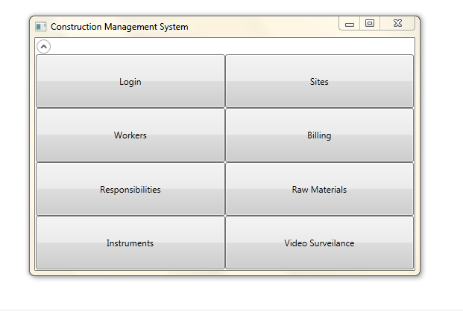

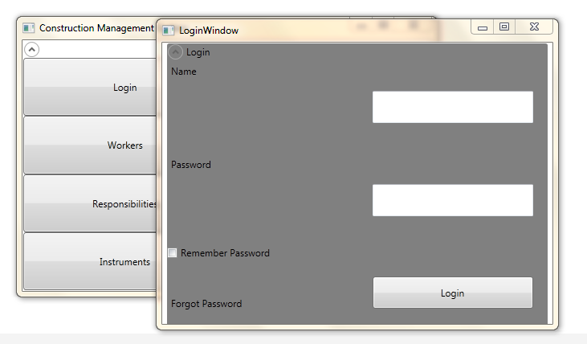

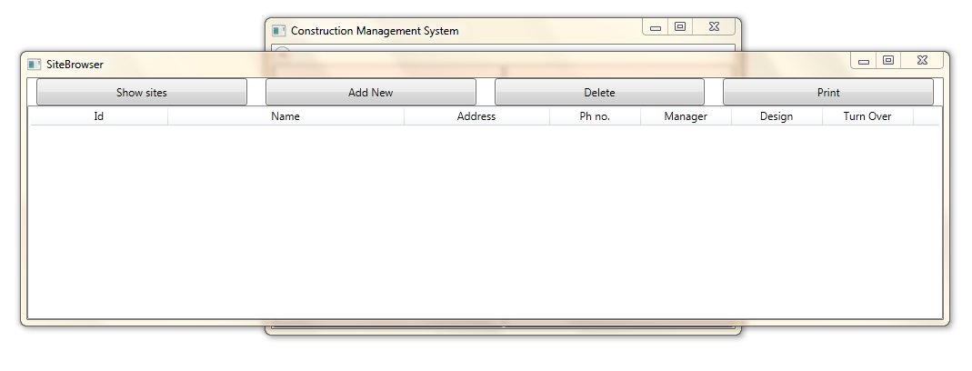
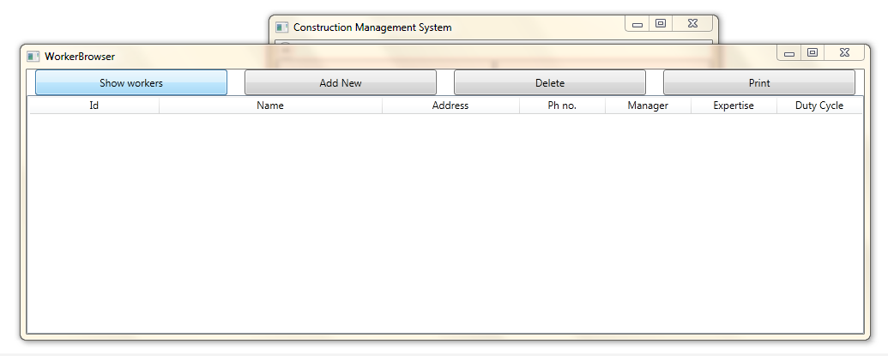

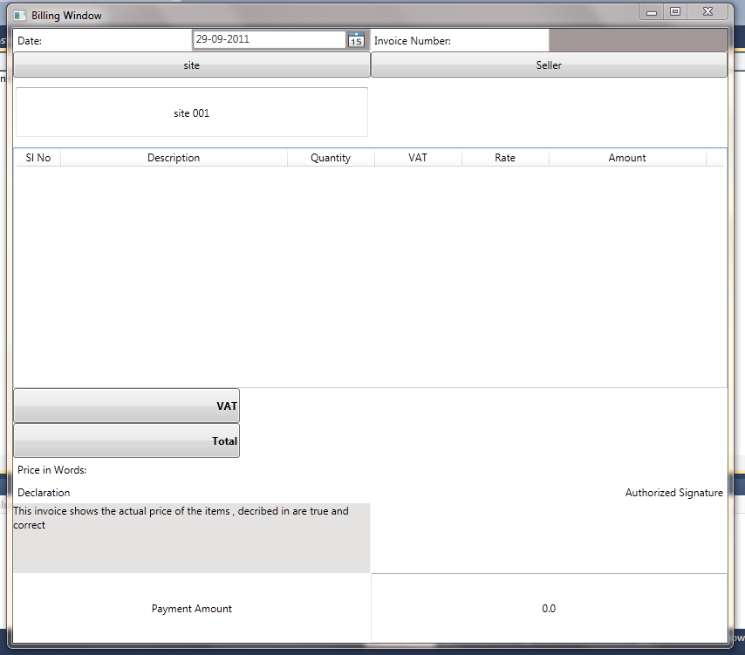

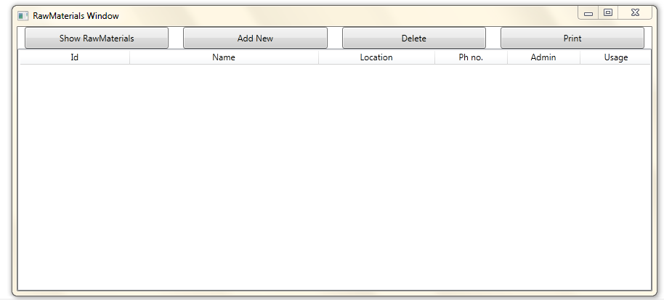

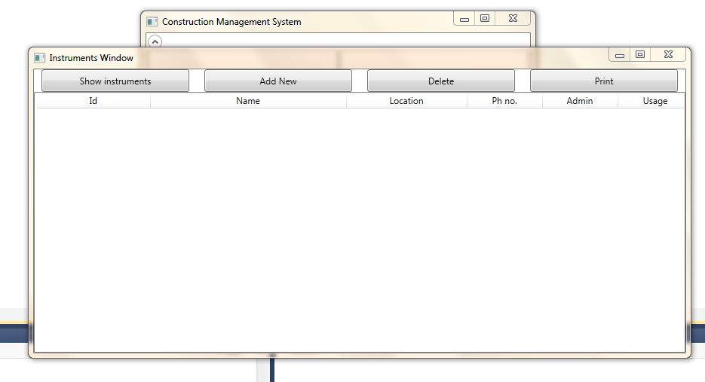

Installer Design:
We are Using Visual Studio Installer to package this software.

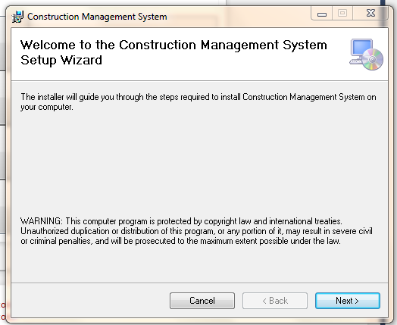
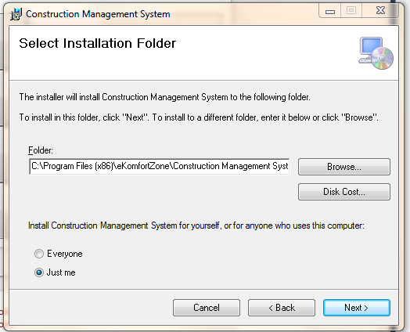
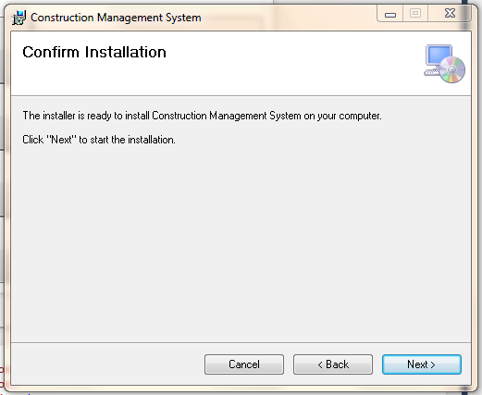
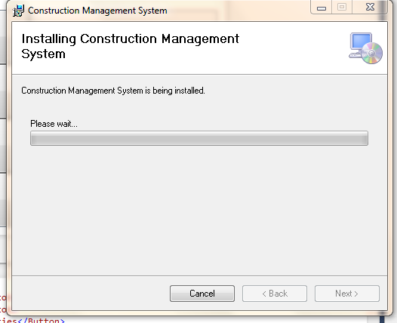
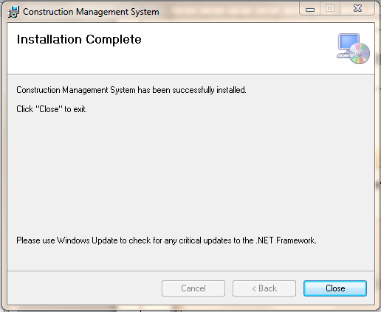

Client/Industry:

E-Komfort Zone
Bamangachi Station Road,
P.O: Bamangachi, P.S: Barasat,
Dist: North 24 Pgs
West Bengal- 743706

Future Scope and Further enhancement of the project:

- To sink with multiple Construction sites with a centralized database.
- To support UNIX / Linux, MAC OSX Operating systems.

BIBLOGRAPHY:

http://www.google.co.in
http://en.wikipedia.org
http://msdn.microsoft.com/en-us/
http://www.microsoft.com/en-us/default.aspx
http://www.codeplex.com/
http://stackoverflow.com/
http://www.codeguru.com/
http://www.w3schools.com

----------------------------- Thank You-------------------------

